Team Members: Daniel Perrotta Nicholas Roy Nicholas Marijon
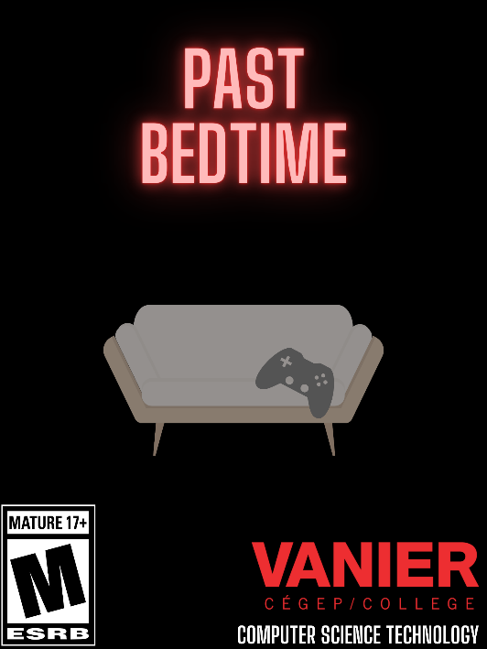
Title: Past Bedtime

Tag line “Play games, solve puzzles, find endings, RUN FOR
YOUR LIFE!!!”

Genre Horror/Story

Target 17+ years old

Goal Solve puzzles and find all the endings.

Draft of Box Art

Plays like FNAF easter egg mini games meets Mandela Catalogue style analogue horror
Popular Game A Popular Game B or twist

Core Mechanics
- Collecting items to solve puzzles
- Sprinting in monster chase sequences
- Switching between mini-game world and overworld
- Multiple endings determined by player choices

Related Games
- Five Nights at Freddy’s 2 – Easter egg minigames / Scottgames / Horror/ PC / 2014
- House / Bark Bark Games / Survival Horror / PC / 2020

Game Project Summary
Supporting Screenshot / Drawings / Collage for Worlds / Levels / Characters / Game Items

Past Bedtime is an innocent looking 2D platformer on the surface, but slowly evolves into a disturbing horror game. About a young boy playing video games until a virus like creature ends his playtime short and will do anything to kill him in the real world. This is a single player horror game that emphasizes using logical thinking like solving puzzles. The focus will be set in two different worlds, the videogame world, and the real world with the monster. There are six different endings and each of them will endure you to use your brain to figure what path you must take to unlock the possibility of getting a different ending.

Pictures below will be used as sprites for the puzzle items in-game:

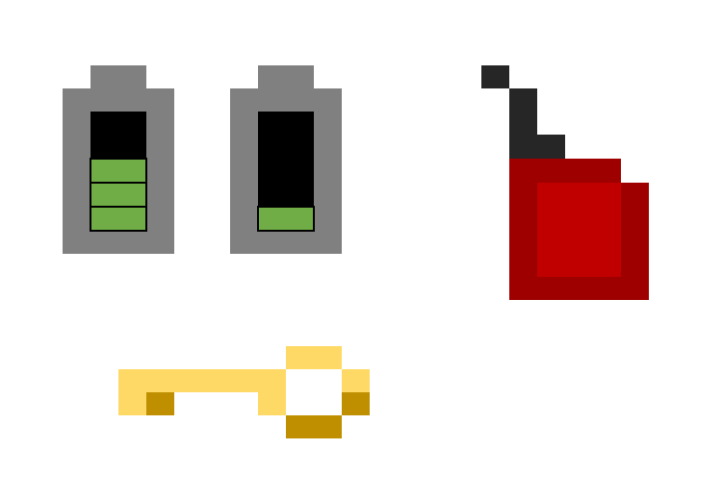
Supporting Screenshot / Drawings / Collage for Worlds / Levels / Characters / Game Items

